FE Payout Pincode Process Manual To Add New Pincode,Area Name & its ICL/OCL Rates

1) PMS Login →Organization Tree → Master → Master → Master

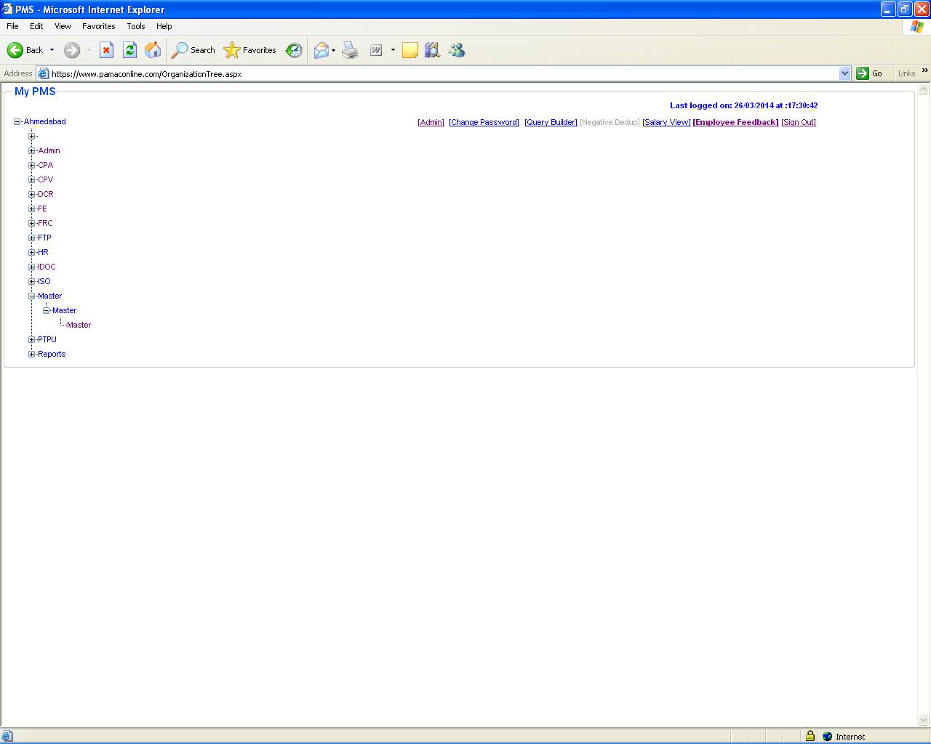
2) Admin → FE-Payout Pincode Master.

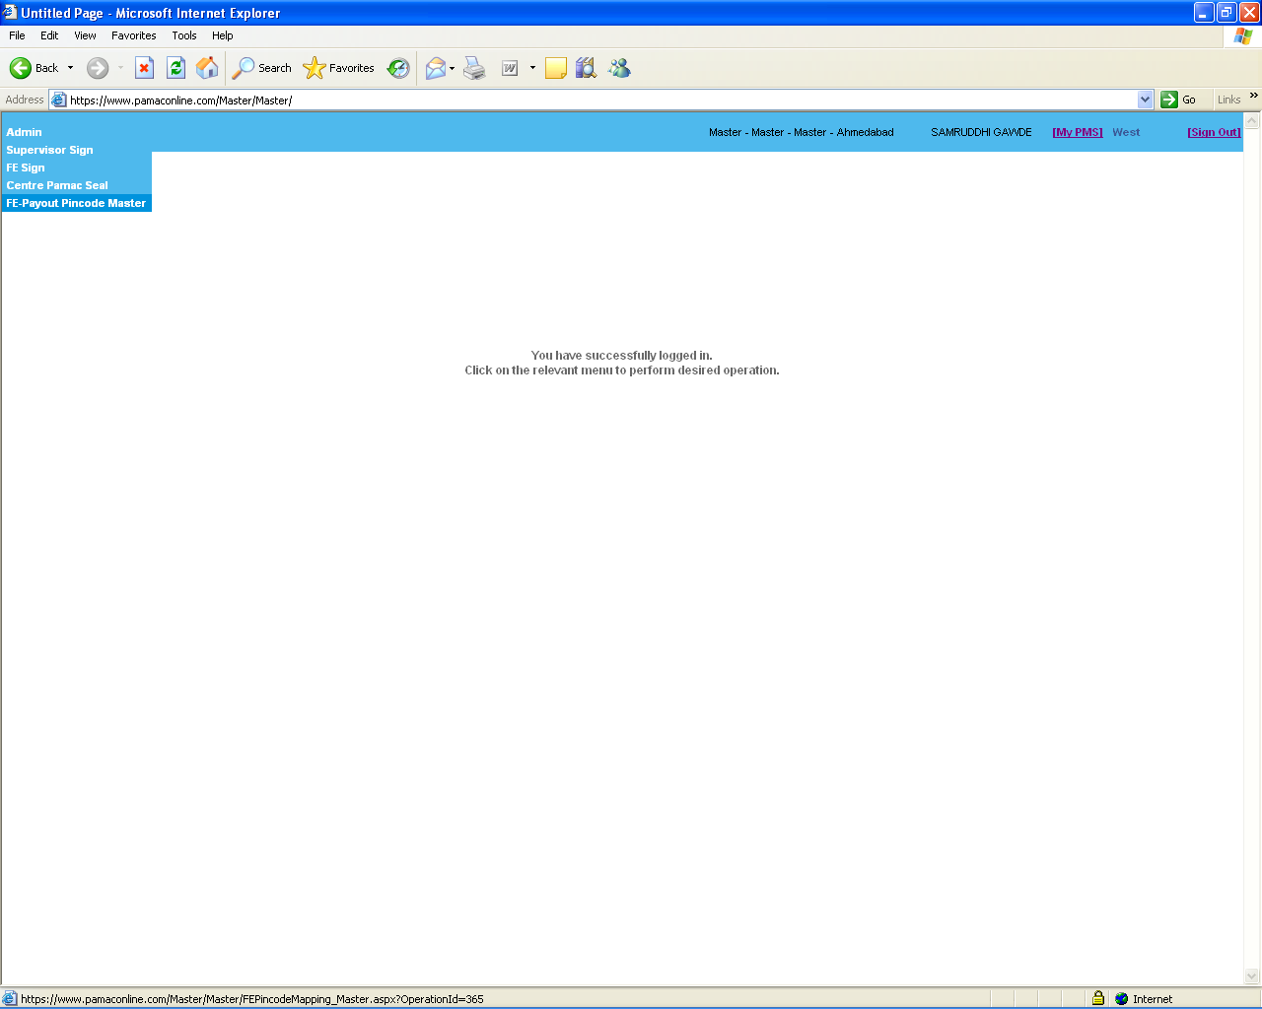
3) User needs to enter Pincode Number, Area Name, Fixed ICL/OCL Rate, Is Active (Yes) details.
- Here, “Pincode No.” must be valid 6 digit number.
- “Area Name” must belong to the Pincode No.
- “Fixed ICL Rate / Fixed OCL Rate” must be numeric or decimal values.
- Select “Is Active (Yes)” only.
- Click “Submit” button after entering all the valid details to SAVE the record.

Click “Add New” button to INSERT new records.(it will clear all the text fields.)

